1. Create a Waterfall chart which would show running total profit over a period of time.

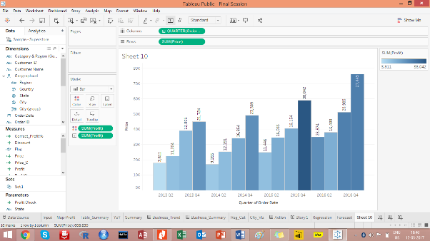

1. The colour of the mark should be red if the profit recorded for that Month is less than the profit recorded compared to previous month, else Green
2. Adjust the tooltip to show as given in the picture below.

